**Beet Seed**

1. B.

2. D.

**Beet Sprout**

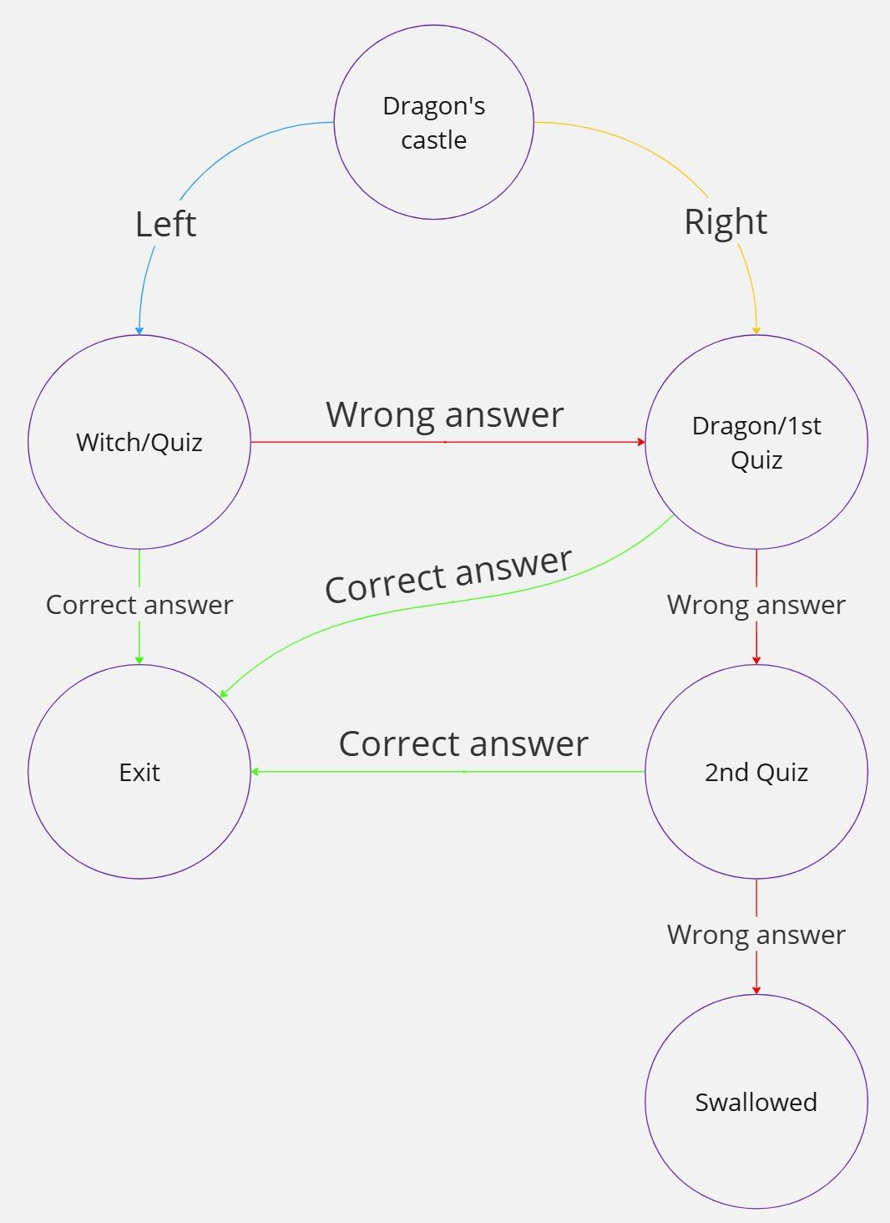

2,3. Чтобы покрыть все состояния необходимо выполнить 2 теста.

Чтобы проверить все обязательные переходы необходимо выполнить 5 тестов (оптимально, согласно целям тест-дизайна).

Чтобы выполнить полное тестирование (избыточное) необходимо выполнить 7 тестов (проходясь по всем вариациям сценария.

**Might Beet**

| **Login** | | |
| --- | --- | --- |
| **Main Success Scenario**  **U: User S: System** | **Steps** | **Description** |
| 1. | U: Enters an email in the “Email” field. |
| 2. | U: Enters a password in the “Password” fields accordingly. |
| 3. | S: Validates email and password data. |
| 4. | S: Allows a user to enter the account. |
| **Extensions** | 1a. | Invalid email.  S: Displays an error message and asks to re-enter the email. |
| 2a. | Invalid password.  S: Displays an error message and asks to re-try the password 2 times. |
| 2b. | Password invalid 3 times.  S: Closes access to the system. Displays an error message to contact the admin. |

| **Add news** | | |
| --- | --- | --- |
| **Main Success Scenario**  **U: User S: System** | **Steps** | **Description** |
| 1. | U: Enters the news in the “News” section. |
| 2. | U: Adds the photos. |
| 3. | S: Validates the “News” field and the “Add photo” section. |
| 4. | S: Allows a user to publish the news. |
| **Extensions** | 1a. | Min character limit issue.  S: Displays an error message and asks to mend this field. |
| 1b. | Max character limit issue.  S: Displays an error message and asks to mend this field. |
| 2a. | Min size limit photo issue.  S: Displays an error message and asks to re-upload a valid file. |
| 2b. | Max size limit photo issue.  S: Displays an error message and asks to re-upload a valid file. |

| **Add a new buddy** | | |
| --- | --- | --- |
| **Main Success Scenario**  **U: User S: System** | **Steps** | **Description** |
| 1. | U: Selects a new friend from the friend list. |
| 2. | S: Validates and compares the buddy with the current friend list. |
| 3. | S: Adds buddy to the friend list. |
| **Extensions** | 2a. | Duplicate record.  S: Displays an error message and refuses a user to add this buddy to the friend list. |
| 2b. | Unlogged user.  S: Displays an error message and refuses a user to add this buddy to the friend list. |

| **Add a “Like” to a buddy’s news** | | |
| --- | --- | --- |
| **Main Success Scenario**  **U: User S: System** | **Steps** | **Description** |
| 1. | U: Sets a “Like” to a buddy’s news. |
| 2. | S: Processes a “Like”. |
| 3. | S: Adds a “Like” to a buddy’s news. |
| **Extensions** | 1a. | Unlogged user.  S: Hide the “Like” mark for unlogged users. |
| 2a. | Marked as liked.  S: Unchecks the “Like” to a buddy’s news. |

| **Shares own news on “Instagram” network** | | |
| --- | --- | --- |
| **Main Success Scenario**  **U: User S: System** | **Steps** | **Description** |
| 1. | U: Selects the news for sharing. |
| 2. | S: Processes the news. |
| 3. | S: Transfers the news to “Instagram”. |
| **Extensions** | 2a. | Unlogged user.  S: Hide the “Share” feature for unlogged users. |
| 3a. | Service unavailable.  S: Displays an error message and asks to share the news later. |

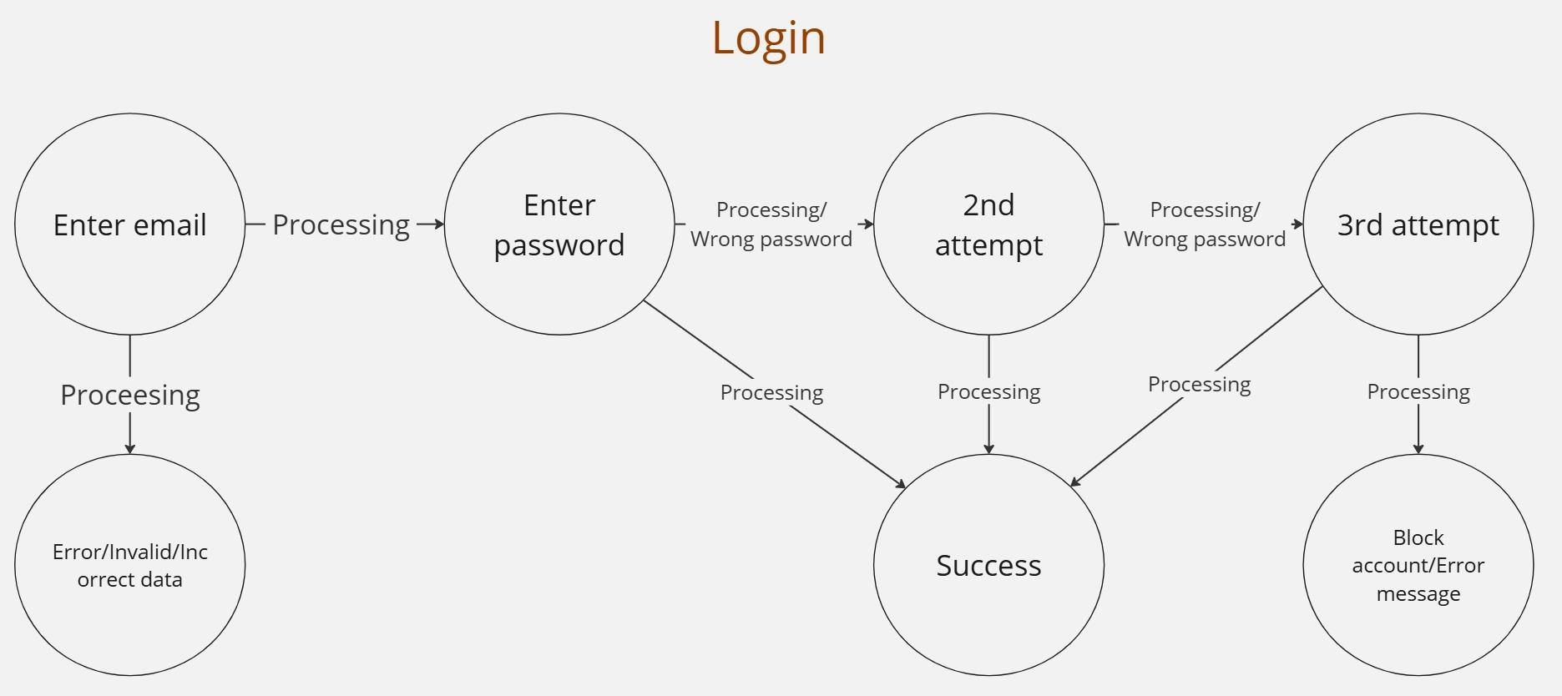

**Login**

| **Fields/Cases** | **TC-1** | **TC-2** | **TC-3** | **TC-4** |
| --- | --- | --- | --- | --- |
| **Email** | T | T | F | F |
| **Password** | T | F | T | F |
| **Result** | T | F | F | F |